## AY2017 Semester 2

|  |  |  |  |
| --- | --- | --- | --- |
| Name |  | | |
| Student ID |  | | |
| Assessment Venue |  | Seat Number |  |

**E356 ESE**



E356: PHARMACEUTICAL AND BIO-CHEM SUPPLY CHAIN

**AY2017 Semester 2 End-Semester Examination (ESE)**

|  |  |  |  |
| --- | --- | --- | --- |
| **Instructions to student:** | | | |
| 1) | Do not turn over this question paper until you are instructed to do so by the invigilator. | | |
| 2) | Write your name, student ID, assessment venue and seat number in the table provided at the top of each page. | | |
| 3) | For this question paper, there are **18** pages (including this cover page). | | |
| 4) | For this assessment, you are allowed to:   * Refer to materials stored in your laptop. * Have only one set of hardcopy notes in bound form, and no larger than A4 size * Have a blank piece of paper for rough working purpose. (Note that the sheet of rough working paper will not be accepted for submission at the end of the assessment.) | | |
| 5) | For this assessment, you are **NOT** allowed to:   * Refer to textbooks and written materials or hardcopy notes in unbound form. * Share any material, such as calculators, with another student. * Communicate with any person other than the invigilator. * Use any communication devices such as handphone or smart watches while at the assessment venue. | | |
| 6) | All rules and regulations pertaining to summative assessments and academic integrity stated in the Student Handbook shall also apply. | | |
|  | ***This segment is to be used by the invigilator only and for ‘online’ and ‘online and paper’ mode assessments only.*** | | |
|  | Please tick the box below if the student has done part of the assessment online: | Invigilator’s Name: | Invigilator’s Signature: |
|  | Partially done online |  |  |

|  |  |  |
| --- | --- | --- |
| ***This segment is to be used by staff grader(s) only.*** | | |
| **Question Number** | **Marks Awarded** | **Max Marks** |
| **1** |  | **25** |
| **2** |  | **20** |
| **3** |  | **23** |
| **4** |  | **24** |
| **5** |  | **8** |
|  |  |  |
|  |  |  |
|  |  |  |
|  |  |  |
|  |  |  |
|  |  |  |
|  |  |  |
|  |  |  |
|  |  |  |
|  |  |  |
|  |  |  |
|  |  |  |
|  |  |  |
|  |  |  |
| **Total** |  | **100** |

# Page 1 of 18



## Question 1 [25 marks]



Jane wants to pack a shipment of 100 ml Japanese Encephalitis virus (cultures only) with 5 kg of dry ice, using a UN certified box as shown in Figure 1a below. The shipment is from Singapore to United States by air.

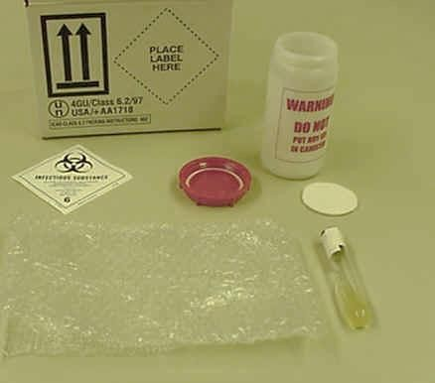

A

B

C

Figure 1a. UN certified box

1. Identify the component labeled ‘A’ in Figure 1a. What is the minimum size requirement for this component?

(2 marks)

1. Identify the component labeled ‘B’ in Figure 1a. What is the minimum internal pressure that this component must be capable of withstanding?

(2 marks)

1. Identify the component labeled ‘C’ in Figure 1a.

(1 mark)

1. An itemized list of contents must be packed into the package, state where you would place the list of contents.

(1 mark)

1. Jane’s shipment contains 100 ml of Japanese Encephalitis virus (cultures only) with 5 kg of dry ice in one package, identify suitable type of aircraft for this shipment. **Justify** your answer.

(2 marks)



1. Jane just received a newly discovered infectious virus from her client. She was not able to identify which Category (A or B) it falls under, after she had searched many resources. However, she needed to properly pack it immediately.

Suggest proper i) Packing Instruction, and ii) Packing Group to her. **Justify** your answer.

(3 marks)

1. After packing, Jane would like to know which airline would accept the shipment. Which session in the IATA DGR manual can she refer to?

(1 mark)

1. Jane packed this shipment with dry ice, state the temperature that the shipment can be maintained at using dry ice and the term given to the temperature range that dry ice can maintain.

(2 marks)

1. For the shipment of 100 ml Japanese Encephalitis virus (cultures only) with 5 kg of dry ice in one package, help Jane fill in the required information in A, B, C, D, E and F on the Dangerous Good Declaration (DGD) Form as shown in Figure 1b below. Please label your answers with A, B, C, D, E and F respectively.

(6 marks)

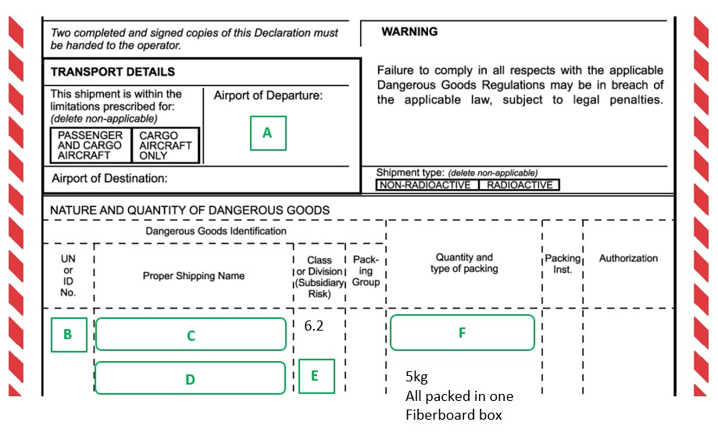

Figure 1b. Dangerous Good Declaration (DGD) Form

1. Jane understands the importance of maintaining the temperature of some virus; she wants to state the range of temperature that the virus should be maintained. Hence, she placed a label stating “**Store between 2 – 8 degrees**” on the outer carton. Identify the potential problems that might arise based on her label and state how it should be labeled to avoid confusion.

(3 marks)

1. Jane printed out the required number of DGD forms and was about to send out her shipment. When she realized that her contact number was typed wrongly, she decided to use a pen to cancel the contact number by striking it through “~~+65~~

~~43219876”~~ on the DGD form and write the correct number beside what she had cancelled. Will such a DGD form be accepted? **Explain**.

(2 marks)



## Question 2 [20 marks]



Steven is the Logistics Manager in the Materials Management Department of MCM Hospital, taking care of the medical and non-medical inventories. His tasks range from procurement of the inventories to disposal of the wastes when necessary.

1. Steven insists that all users of the consumables in the hospital to go through proper PO requisition. Why is this important to the hospital?

(2 marks)

1. Steven needs to ensure the bio-waste generated in the hospital is cleared off-site. Where will usually this location be? Suggest **THREE** (**3)** reasons why off-site treatment of bio-waste is preferred in Singapore.

(4 marks)

1. In MCM Hospital, different types of healthcare waste are generated. Based on the classification of healthcare waste by WHO, state the class of healthcare waste that the following items (in Table 2a) fall under.

(3 marks)

Table 2a. List of Healthcare Waste

|  |  |
| --- | --- |
| **Healthcare Waste** | **Class** |
| Expired drugs |  |
| Used syringe needles |  |
| Organs or body parts removed during surgery |  |

1. Figure 2b below shows a biohazard bag. State and explain if it is suitable to use this bag for the disposal of the “Used syringe needles”.

(2 marks)

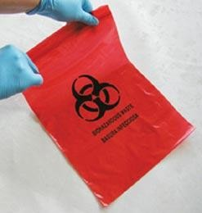

Figure 2b. A biohazard bag

1. A clinical trial to test the new drug for the treatment of Dengue Fever was conducted recently in MCM Hospital. Dengue Fever is infectious and severe cases may result in deaths. Answer the following 2 questions (Please label your answers properly):
   1. State the total number of phases in a clinical trial.

(1 mark)

* 1. Identify the clinical trial phase that tests on the toxicity and safety of the drug.

(1 mark)

1. Recently, Steven has also been tasked to look after the auxiliary supplies for clinical trials. Explain what auxiliary supplies for clinical trials are, and name **TWO (2)** of such examples.

(3 marks)

1. There are cold chain shipping boxes used for shipping temperature-sensitive vaccines to some of the off-site nursing homes near the hospital. Before Steven can issue these boxes, he needs to have the product performance summaries of these boxes. Why is it important to have these summaries before he can use the boxes?

(2 marks)

1. One of Steven’s colleagues needs a shipping system for stem cells, using liquid nitrogen as the refrigerant. Can Steven use one of the shipping system that is designed for dry ice as a refrigerant? **Explain** your answer.

(2 marks)



## Question 3 [23 marks]



For each of the scenarios in question a), b) and c) below, name the type of license you need to apply for and the agency/agencies to which you need to apply in Singapore.

1. Sell traditional sore-throat capsules, classified as Chinese Proprietary Medicine (CPM), to local pharmacies and clinics.

(2 marks)

1. Manufacture Potassium Chlorate, which is an explosive chemical.

(2 marks)

1. Import and sell Hydrogen Cyanide 0.5% weight in weight, used as a lab reagent.

(2 marks)

1. Transport 2 metric tons of paints (Class 3 Dangerous Goods) by land in Singapore.
   1. What are the necessary approvals needed for this shipment?

(3 marks)

* 1. Does the vehicle need to install HAZMAT Transport Vehicles Tracking System? Why or why not?
  2. What is the approved timing for this shipment?

(3 marks)

(2 marks)

1. The driver of the licensed vehicle which carried Hazardous Substances (HS) followed the approved transport route from the warehouse at Jurong to the client site at Changi. After unloading all the HS goods at Changi, he decided to travel via MCE Tunnel back to Jurong in order to save time.

What is/are the consequence(s) of his decision? What does he need to do in advance so that he is allowed to travel via MCE Tunnel back in this case?

(4 marks)

1. Three small cards which are circled in Figure 3a below are attached to a vehicle to indicate information about the contents (e.g. Dangerous Good) of the vehicle, what is the requirement on the dimension of the small card?

(2 marks)

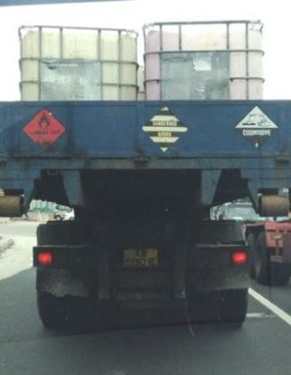

Figure 3a. Three “small cards” attached to a vehicle

1. Figure 3b below shows a portion of Safety Data Sheet (SDS) of potassium borohydride, which is one of dangerous goods.

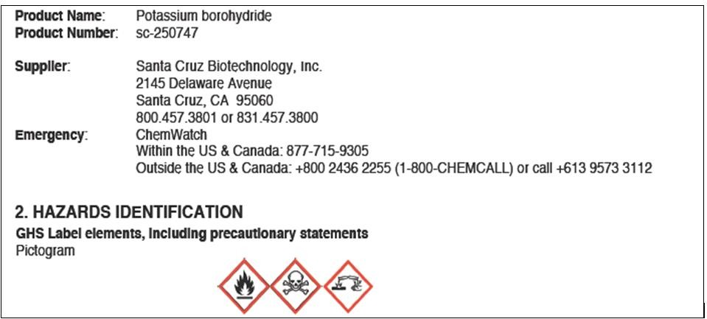

Figure 3b. A portion of Safety Data Sheet (SDS) of potassium borohydride

In order to create a GHS Label for this product, apart from the information available in Figure 3b, what is/are the other information that you need to extract from its SDS?

(3 marks)



## Question 4 [24 marks]



Juz Pharma specializes in the storage and distribution of healthcare products in Asia Pacific. Juz Pharma also provides value added services to its principals; to assure its principals that their products are consistently prepared, handled and stored along the supply chain, the company has adopted GMP/ GDP throughout its distribution centre operations.

1. Under the GMP / GDP guidelines, there should be sufficient security to prevent unauthorized access and misappropriation of the goods. Suggest and briefly explain how this guideline can be implemented in Juz Pharma.

(2 marks)

1. The GDP guidelines also state that *“Products should be transported in such a way that they are secure and not subjected to unacceptable degrees of heat, cold, light, moisture or other adverse influence, nor to be attacked by microorganisms or pests.”* Suggest how the temperature of deep frozen shipments (e.g. ice cream) can be maintained during transportation by normal truck.

(2 marks)

1. One of the pharmaceutical products that Juz Pharma stores is “VegeC” tablets which come in different strengths, i.e. 500mg, 400mg and 250mg. Juz Pharma received complaints from clinics, claiming that they had received 400mg tablets packed in cartons that were labeled 500mg.

Can the “VegeC” tablets that the clinics received be considered a counterfeit medicine?

**Justify** your answer.

(3 marks)

1. With the mislabelled “VegeC” tablets in the market, Juz Pharma decided to recall all the “VegeC” from the retailer and patients back to the distribution centre. Identify the level of recall in this case.

(2 marks)

1. Is this a “Class 1” or “Class 2” recall? **Explain**.

(2 marks)

1. From the time Juz Pharma decided to trigger a recall, how much time did they have to inform HSA about the recall?

(1 mark)

1. After the recall was confirmed by HSA, and affected parties had been informed, how much time did Juz Pharma have to complete the recall process?

(1 mark)

1. After all the mislabelled “VegeC” was recalled, Juz Pharma changed the cartons to reflect the correct strength of 400mg. Can these items be returned to the market for sale? **Explain**.

(2 marks)

1. Juz Pharma has to comply with GMP as the company has been involved in secondary manufacturing. What are the differences between primary and secondary manufacturing?

(2 marks)

1. Stickers like those shown in Figure 4a below are also commonly applied onto pharmaceutical packages. Identify the type of anti-counterfeiting measure and **THREE**

**(3)** benefits of using this feature.

(4 marks)

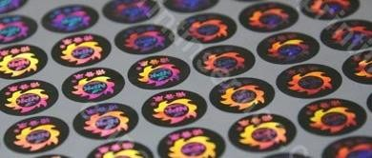

Figure 4a. Stickers on some pharmaceutical packages

1. Suggest **THREE (3)** ways in which track and trace methods used on drugs can help to meet GMP or GDP requirements.

(3 marks)



## Question 5 [8 marks]



Heart attack is the number 2 killer in Singapore, according to National Heart Centre. William is a businessman and owner of a new company distributing medical devices within Singapore. He wants to bring in a new brand of vascular stent, a medical device used to prevent localized blood flow constriction.

1. Identify the class of medical devices that “vascular stent” belongs to, based on HSA’s guidelines. **Justify** your classification.

(3 marks)

1. The use of Automated External Defibrillation (AED) can greatly improve the survival rates for people suffering from cardiac arrests.

The AED consists of defibrillation pads and electrodes - what is the classification for these devices, and which rule under GN-13 does it follow? **Explain** your answer with justifications.

(3 marks)

1. Recently, William plans to import a Class B medical device XYZ from USA and export to Malaysia. XYZ is not sold in Singapore. What is the certificate or document he needs to submit to HSA in this case?

(2 marks)

## END OF PAPER